**Assignment 6**

**Problem Statement:**

You work for a corporation that uses on premise solutions and some limited number of systems. With the increase in requests in their application, the load also increases. So, to handle the load the corporation has to buy more systems almost on a regular basis. Realizing the need to cut down the expenses on systems, they decided to move their infrastructure to AWS.

**Tasks To Be Performed:**

1. Use the Route 53 hosted zone created in the assignment.

2. Route the traffic to an EC2 instance with an Apache web server running in it using its IP address.

**Solution:**

Step 1:- Buy a domain from hosting sites. Then create a EC2 instance with web server. Then go to route53 hosted zones & create one.

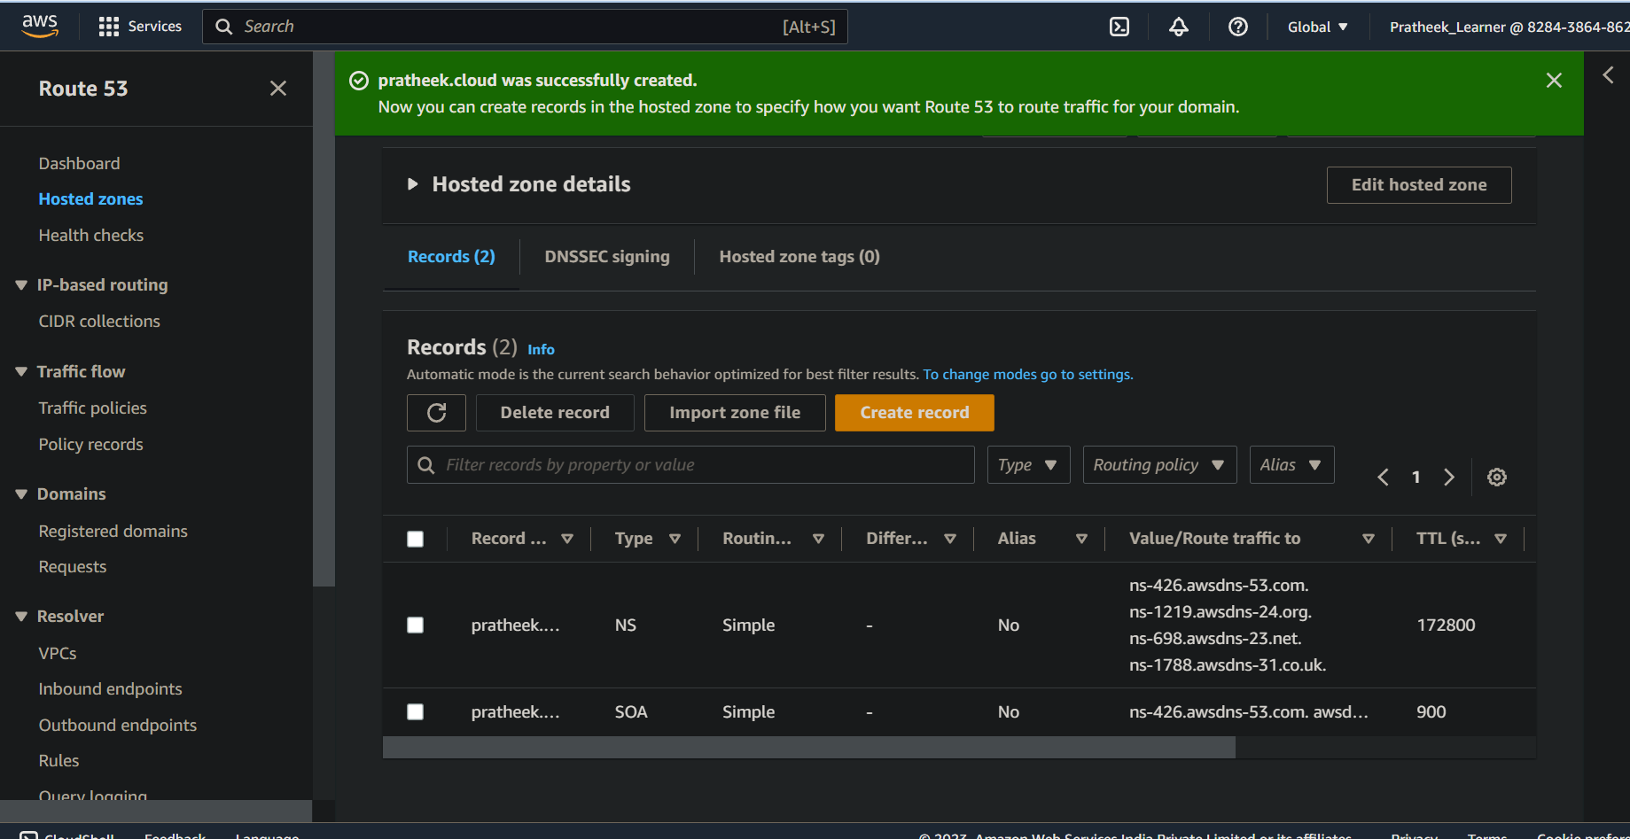

Step 2:- Now integrate the nameservers given in Route53 to the nameservers that we got from the webhosting site.

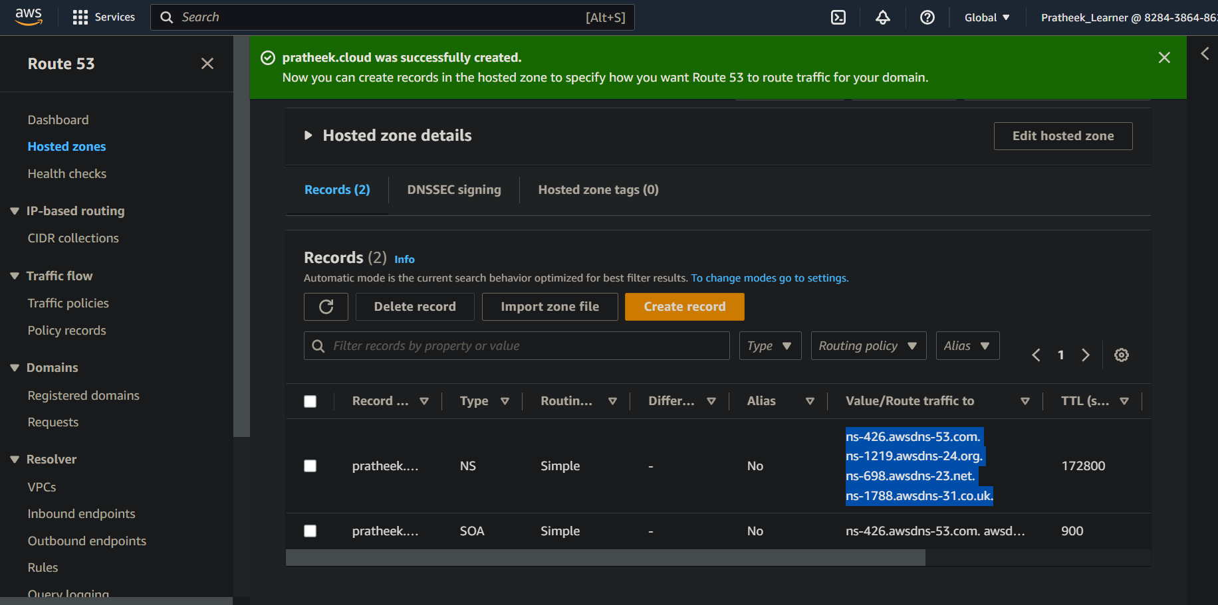

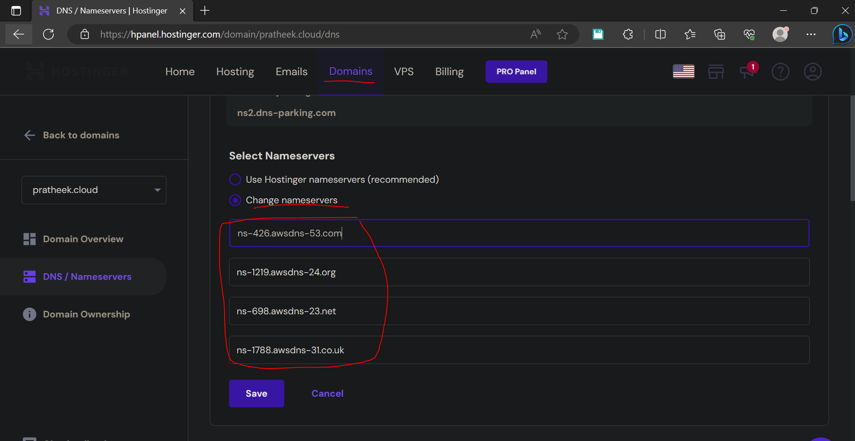

Step 3:- After this we have to create a record for routing policy

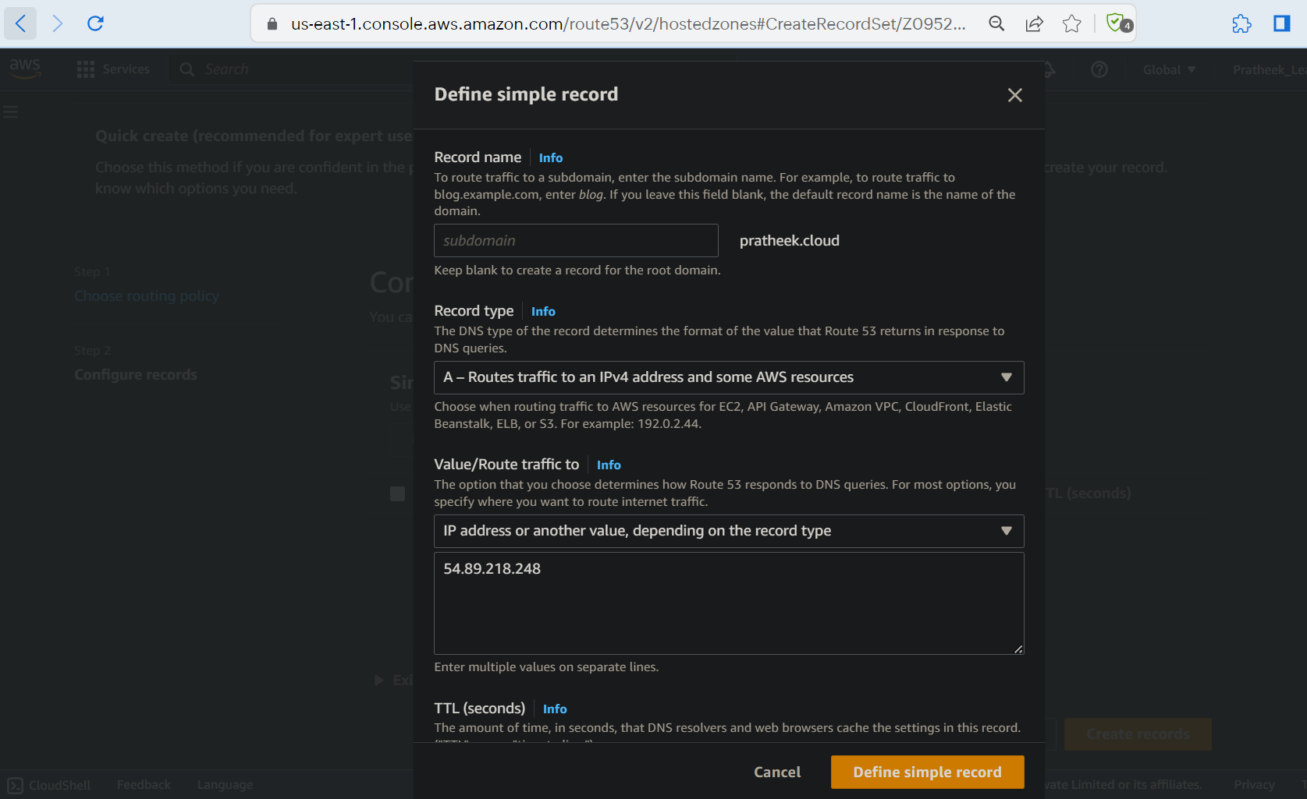

Step 4:- After creating the record policy, go to the domain that we got & it should redirect to the EC2 web server.

